Marble Hill Neighborhood map

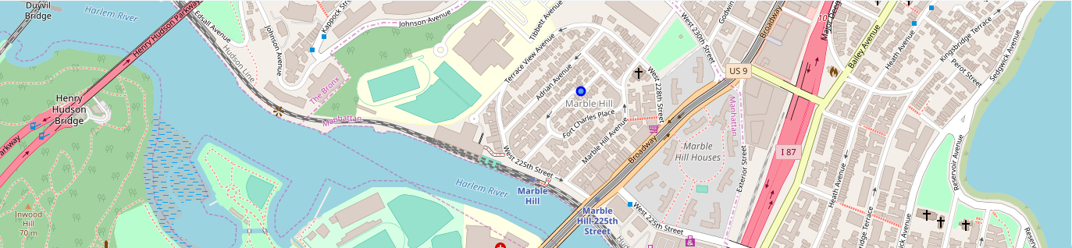

Top venues in Marble Hill

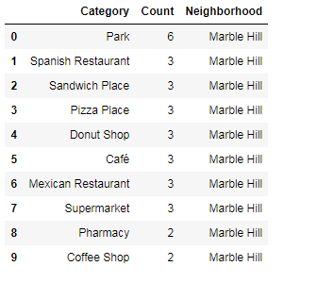

Toronto Neighborhood map

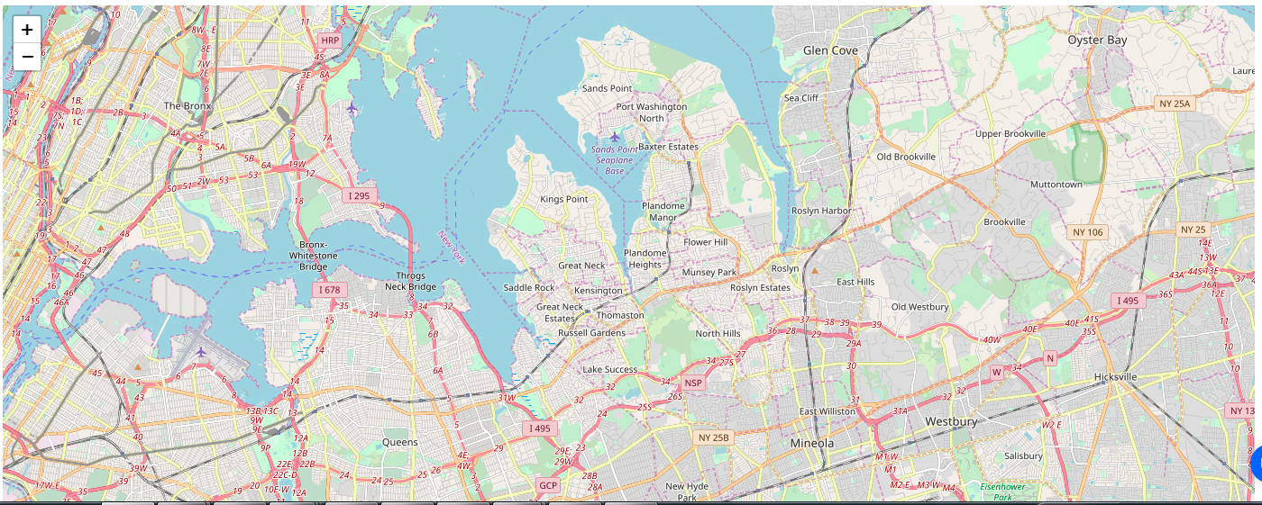

Similar Venues in Toronto compared to Marble Hill

